Day 10 Lab

Questions
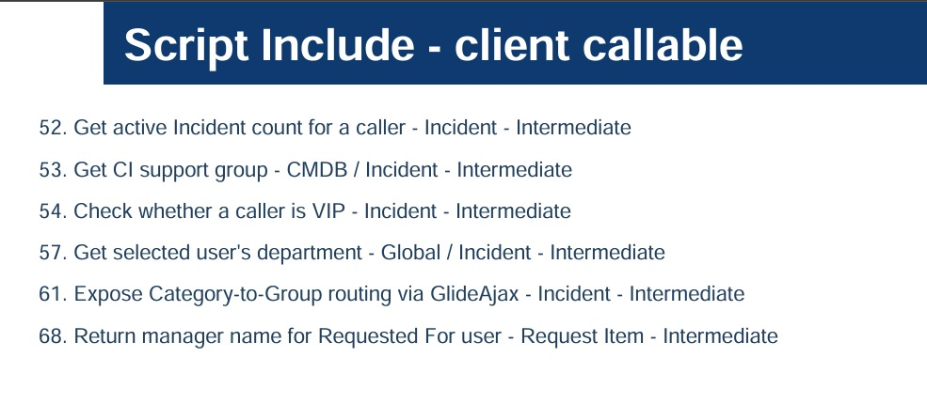

Answers
52. Get active Incident count for a caller - Incident – Intermediate
Script includes:
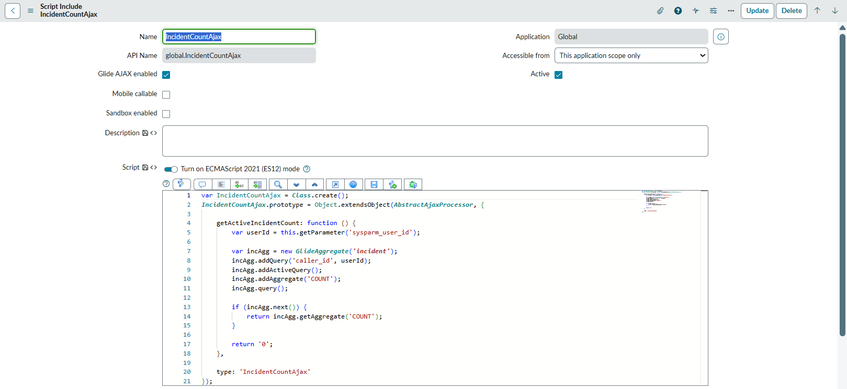
Client Script:
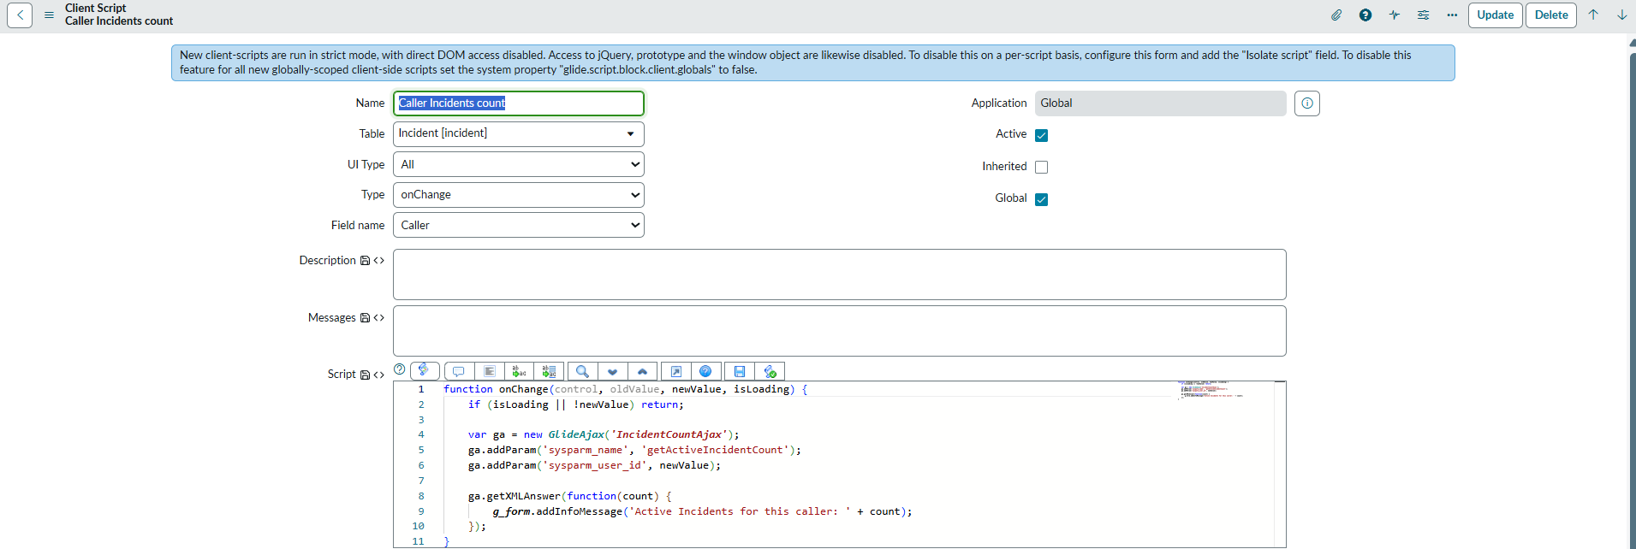

Answers
54. Check whether a caller is VIP - Incident – Intermediate
Script includes:
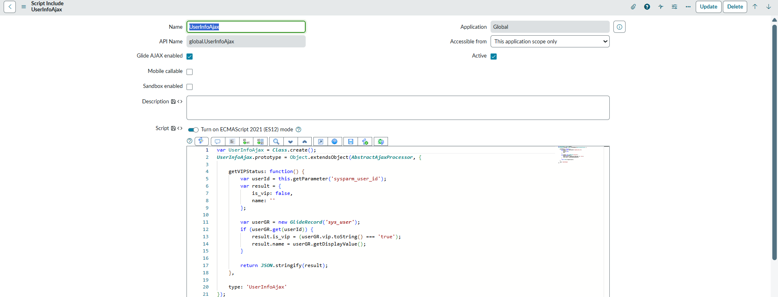
Client Script:
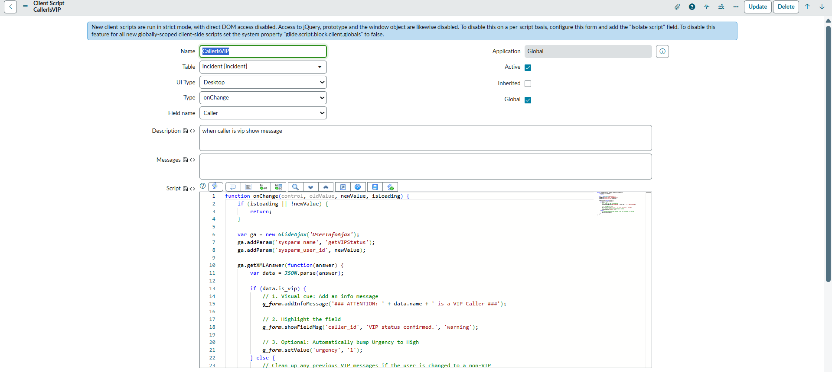

Answers
57. Get selected user's department - Global / Incident – Intermediate
Script includes:
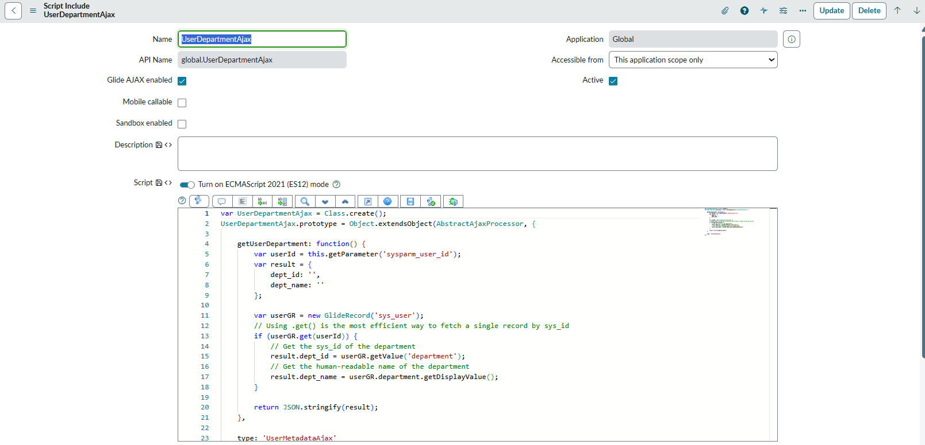
Client Script:
